Assignment 2: Dashboard
Team members: Sofiya Karpova, Egor Konstantinov, Andrei Velicorodnov

Business description
"Digital Horizon" Online School - an EdTech startup providing systematic, practice-oriented education in economics and business for students of schools, colleges, universities.
Unique value proposition: "Education without borders: international experience and multilingual learning in one online school" (courses in English, single consultations, real business case studies).

Business requirement for the dashboard
- Description of the business problem(s):
Digital Horizon Online School faces inefficient student support in active chat channels. Before the AI agent, response times were slow, answers were inconsistent, and support demand spiked around lessons and exams. This created high manual workload, increased labor cost, and a risk of lower student satisfaction. The core business problem is how to improve speed and consistency of support without expanding the support team.
As-Is: human-heavy support, slower first response, higher escalation, inconsistent answers, limited visibility into performance.
To-Be: AI-assisted support with faster responses, more chats resolved without human intervention, more consistent answers, and structured logging for management analysis.
- Dashboard goals:
The dashboard is designed to monitor whether the AI Support Agent improves operational efficiency and service quality compared with the pre-AI baseline. Its goal is to provide a clear before/after view of support performance, identify where the AI creates value, and show where human intervention or KB improvements are still needed. It also supports ongoing management of the knowledge base and system performance by highlighting topic concentration, unresolved issues, and alarm conditions.
- Key questions that the dashboard should answer:
1. How did the core support KPIs change after the AI agent was introduced?
2. How much operational workload has been shifted from human support to AI?
3. Which support topics generate the highest chat volume and the highest escalation or abandonment rates?
4. Is service quality being maintained while efficiency improves?
- Target audience:
The main target audience is the management team of Digital Horizon, especially the CEO and operational managers, who need a clear view of whether the AI Support Agent is improving efficiency, reducing support costs, and maintaining service quality. The dashboard is designed as a decision-support tool to help leadership monitor performance, identify inefficiencies, and make optimization decisions about staffing, support processes, and Knowledge Base improvements.
Data preparation
- Data descriptive statistics were used to summarize the main numerical fields in the dataset, such as FRT, Resolution Time, number of messages, and CSAT. Mean, median, and mode were calculated to show typical values, while min–max range and standard deviation were used to measure variation. Histograms were also reviewed to understand the distribution of the data and identify any outliers or skewed patterns.
- Data cleaning and transformations performed:
Duplicates were removed, timestamps and categories were standardized, numeric KPI fields were validated (missing values/outliers checked), binary flags were created for escalation/AI-resolution/reopen, and records were labeled as Pre vs Post. KPI rates and daily aggregates were then calculated to support dashboard visualizations (averages, percentages, and changes).
2. Dashboard design
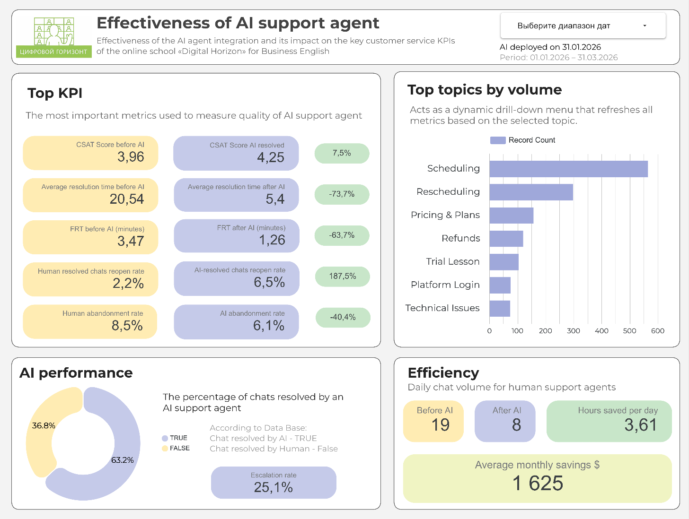
3. Link to the dashboard
https://lookerstudio.google.com/u/0/reporting/089f2062-2c3e-412c-a034-f8816d41dc3b/page/yxHrF
4. Dashboard Alarms
1. CSAT < 4.0. A score of 4.0 is the “good” grade on a 1–5 scale. Below 4.0, neutral and negative ratings become noticeable, which usually signals a real quality decline. This is an early warning before CSAT slips into clearly poor territory (around 3.7–3.8).
Call-to-action: review recent low-CSAT conversations, find repeating failure patterns, update the knowledge base and response wording.
2. Escalation Rate > 40%. If more than 40% of chats are escalated, the AI is containing less than 60% of demand. At that point it is no longer reducing workload effectively and is acting more like a filter. This benchmark is high enough to indicate a structural issue.
Call-to-action: identify the top escalation topics, fill gaps in intents and articles, improve clarification prompts, tune handoff rules.
3. Abandonment Rate > 10%. When abandonment goes into double digits, users are leaving before getting help. This is typically caused by slow first responses, unclear answers, or no obvious next step. The 10% threshold separates normal “noise” (accidental exits) from a sustained experience problem.
Call-to-action: check first response time, review the first two bot messages, remove looping questions, make responses more step-by-step.
4. First Response Time > 2.0 min. Two minutes is a strong early warning relative to the post-AI baseline. In our data, post-AI FRT is about 1.26 minutes, so 2.0 minutes is roughly a 1.5× slowdown that users will feel. It also triggers well before you drift back toward the pre-AI level (around 3.47 minutes).
Call-to-action: inspect routing and queue delays, bot trigger timing, peak time windows.
5. Resolution Time > 10 min. Ten minutes is close to a 2× deterioration versus the post-AI baseline (about 5.4 minutes). That usually means conversations are getting stuck, the knowledge base is missing key steps, or complex cases are not being escalated early enough. It is still far from the pre-AI baseline (about 20.5 minutes), so it works as a guardrail.
Call-to-action: find the topics driving long resolutions, add guided flows, improve article coverage, and adjust early escalation rules for complex cases.
- Review of another dashboard
Reviewer: Sofiya Karpova and Egor Konstantinov
Dashboard being reviewed: Monthly Sales Performance Dashboard
Dashboard being reviewed created by: Noor Muhammad

Part 1: Summary & First Impressions (The “What”)

This dashboard is designed to monitor monthly sales performance, including total sales, profit, discount, quantity, sales by category, profit by region, and top customers. The main business issue it addresses is tracking overall sales results and understanding which products, regions, and customers contribute most to performance.
The primary user appears to be a sales manager, business analyst, or regional manager who needs a quick overview of business results.
Our first impression is positive: the dashboard looks organized and professional, and the purpose is clear right away. The KPI cards at the top make the most important numbers easy to spot. At the same time, the page feels a little crowded, so some visuals take more effort to read than they should.

Part 2: Analysis of Strengths (“What Works”)

One clear strength is the top row of KPI cards. Showing Total Sales, Total Profit, Average Discount, and Total Quantity at the top gives the viewer an immediate summary of performance. This is effective because the user can understand the overall business situation before moving to more detailed charts.
Another strength is that the dashboard covers several useful business dimensions at once. It does not focus only on sales totals, but also includes product sub-categories, category distribution, regional profit, monthly comparison, and top customers. This makes the dashboard more useful for decision-making because it helps users see performance from different angles.
A third strength is the general layout and structure. The information is arranged in a logical way: summary numbers first, category and regional breakdowns next, and more detailed charts and customer information below. This makes the dashboard fairly easy to follow, especially for someone who wants a quick business overview.

Part 3: Constructive Critique & Recommendations (“What Could Be Improved”)

A. Clarity & Usability

One issue is that some of the colors blend together. Since many visuals use similar shades of blue, it can be hard to quickly distinguish between different months or categories. This reduces clarity, especially in charts with multiple series.
A good improvement would be to use more contrasting colors or at least more clearly separated shades. That would make comparisons faster and easier.
Also, some charts feel a bit busy, especially the product sub-category chart and the sales trend chart at the bottom. There is a lot of information on one page, so the user may need extra time to understand everything.

B. Strategic Relevance

The dashboard gives a solid overview of performance, but it would be even more useful if it showed business targets or comparisons. Right now, we can see the numbers, but we cannot immediately tell whether the results are above or below expectations.
Another thing missing is the company name. The dashboard has a nice title, but there is no company identity or brand name, so it feels slightly generic.
Adding the company name and short description would make the dashboard feel more complete and professional.

C. Data Storytelling & Context

The dashboard includes good information, but it does not fully tell a story yet. For example, it shows sales, profit, categories, and regions, but it does not clearly highlight the most important takeaway.
It could be improved by drawing more attention to the main insight, such as which category performs best, which region is weakest, or whether current sales are improving compared to previous months.

D. Visual Design

The visual design is overall clean, but a few elements could be refined. The main issue is that the dashboard feels a little crowded, and the similar blue tones make several visuals look too similar.
Adding a bit more spacing between elements and improving color contrast would make the page easier on the eyes. The design is already good, but these small adjustments would improve readability and make the dashboard stronger overall.

Conclusion

Overall, this is a well-structured and useful dashboard with clear business value. It does a good job of presenting key sales information in one place, and the KPI cards and layout work well. The main areas for improvement are making the visuals easier to distinguish, reducing the crowded feeling a little, and adding the company name for better context and professionalism.

